Iver Heath Bowls Club
New members’ guide



We are delighted that you have joined our friendly club.

Bowls Buddy
We will buddy you up with an experienced bowler for your first year. They will help you learn the ropes and get settled.

Your buddy is……………………………………………………………………………………………………………………………………………………..

…………………………………………………………………………………………………………………………………………………………………………………………………………………….

Welcome to Iver Heath Bowls Club
This guide is intended for all new members, particularly new bowlers.
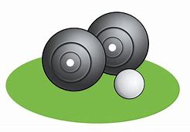

Get bowling!
You will be introduced to our club coaches and maybe you have already had a few lessons. You will need to be signed off by a coach before you can use the green on your own. You can then start playing in midweek and weekend friendlies. Do this as soon as possible. You will be in a team of three or four and everyone will be really supportive. Don’t worry, have fun and just learn the ropes.
During the summer season on Friday evenings we try to organise a Roll Up. Come on down, borrow some club bowls and we will arrange some games for fun. Sometimes we may have a BBQ. or you can just have a drink and watch.
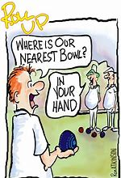

Fixtures and Competitions
The fixtures booklet you have been given contains details of the friendly midweek and weekend games between Iver Heath and
Fixtures and Competitions
The fixtures booklet you have been given contains details of our matches, including the friendly midweek and weekend games between Iver Heath and other clubs. If you wish to play you must sign up on the lists in the entrance hall. The selection will go up a few days before the game and you will find out if you have been selected and who you are playing with. Match fees are typically £2-£4 and this may include a light supper after the match.
A match is usually in one of the following formats:
• Singles – one player per team, with four woods per player; first to score 21 shots is the winner
• Pairs – two players per team, usually with four woods each, played over a set number of ends (usually 18 or 21)
• Triples – three players per team, usually with three woods per player, played over a set number of ends (usually 18)
• Fours (“Rinks”) – four players per team, with two woods each, played over a set number of ends (usually 18 or 21)
At the end of the game it is traditional for the home players to buy a drink for their opposite number. There may also be a raffle with the opportunity to win some prizes!
Arrive about 30 minutes before a game. Ladies usually arrive in their greys or whites and change into their bowling shoes. Men will arrive in grey trousers, white shirt, change into their bowls attire.
There are other club competitions, county matches, leagues etc also listed in the fixture book. You will learn about them in due course.
Changing rooms – ladies can ask Betty if there is a locker available.
Some members leave their cases and bowls in the changing rooms between games at their own risk. We ask that you keep them tidy and take your possessions home at the end of the summer season.

THE CLUB HOUSE
The club is open every day during the summer season. From 10.00am at weekends and 12.00 midday during the week.

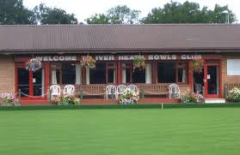

You can come along and have a roll up if there is a rink free. Just check the rink folder on the table by the kitchen. During the summer months, particularly June, July and August there are usually matches going on every evening and there is no better way to pass some time with a coffee, beer or glass of wine.
You are welcome to bring guests up to 6 times each year, but please do not let them on the green.
The social aspect of our club is key with members forging lifetime friendships.
DRESS CODE
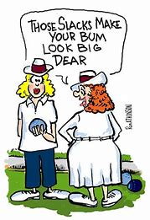
Details are at the back of
the fixture booklet.

Generally:-
Weekend games- whites
Midweek games - club shirt and greys
Roll up - Greys and plain white top.
Winter indoor shortmat– anything
Any shoes are fine but they must have a flat sole.
Egham Bowls Club has a shop. Check the website for opening hours.
You may be able to pick up some used bits and pieces so look for adverts on clubs’ notice boards. Alternatively you can look online.

WINTER SEASON
During the winter we play indoor bowls on a full size green at local clubs once a month. Sign up in the usual way.
We also have short mats at our club on one afternoon and evening. It is very informal and fun.
There are also many social events such as Bingo, quizzes, Sunday lunches and Christmas and Burn’s night meals. Look out for details in Betty’s emails or on the club noticeboards.
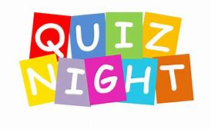   |  | 
  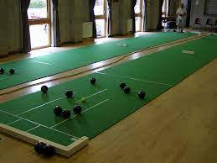 |  | 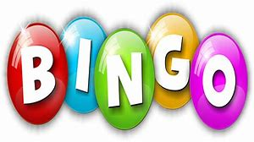

Our walking group meets

once a week throughout the
year with short local walks
followed by a pub lunch.
Contact Cathy May for details.
GETTING INVOLVED AND VOLUNTEERING
We like everyone to contribute in some way towards the running of the club. In the first instance here are some things you may be interested in.
- Bar duty – add your name to the rota, see Gordon or Neal
- Helping with post-match teas – see Betty
- Become a member of the green team to help on or around the green.
- Help with the flowers and hanging baskets- see Jan Boulding.
- Maybe you have IT skills or you can help with maintenance or some administration?
All help will be gratefully received.
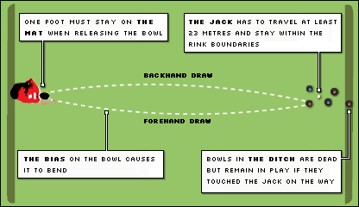

BOWLS ETIQUETTE
Bowls is a friendly game, although some players are more competitive than others! Here are some points of etiquette that may help.
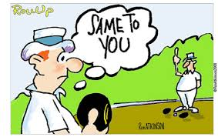
Start and finish the game with a handshake and a smile.
Enter and leave the green by your rink.
On a sunny day make sure that you are not casting a shadow over the head.
When you are waiting your turn to bowl be aware of what is going on around you. Don’t talk when someone is about to bowl and stand behind them.
Remember that no one bowls a bad wood on purpose so encourage all team members.
- Don’t walk on adjacent rinks.
Always stand still at the head and not directly behind the jack or in front of the rink markers.
Greens are delicate and you can easily cause damage. Check that your technique is not causing marks. Never drop or kick bowls.
As soon as your wood comes to rest the possession of the rink becomes the opponents. Wait to ask any questions until the mat is in your possession and it is your turn to bowl.
Never criticise opponents play. Learn to accept “lucky wicks” and shots- they will balance out for and against you in the long run.
- If the bar is open it is usually the home player who asks their opponent if they would like a drink. The visitor can reciprocate later.
- If you are a spectator do not walk in front of a bowler who about to bowl. Stand still. Remember this when you enter the ground.
MATCH POSITIONS
Lead Responsible for placing the mat if your team wins the end, delivering the jack and the first bowl of the match. After the end has been played the losing lead clears the bowls. The lead stands back when the score is being decided.
Two They are responsible for changing the scoreboard in triples. They measure and score in triples.
Three Usually a more experienced player. They advise the skip of the state of play. They measure and score in rinks.
Skip This is always an experienced player. Their bowls will decide the outcome of the end. During play they will decide tactics such as jack length and where to deliver the bowls.

BOWLS LINGO
Backhand When (for a right-handed player) the bowl is delivered so the curve of the bowl is from the left to right.
Back bowl A bowl that finishes behind the head.
Bias The shape of the bowl which causes it to curve.
Blocker A bowl deliberately played short of the head.
Delivery The moment the bowl leaves the hand.
Ditch The gully around the green. If a bowl ends up in the ditch and it is not a ‘toucher’ then it doesn’t count.
Draw A bowl delivered at the correct weight, and with correct line, to arrive where you want.
Drive A shot played with great force.
End The sequence of play from the moment the mat is placed down until all bowls have been delivered. A bit like a game in tennis!
Foot fault If you don’t deliver the bowl with part of your foot on or above the mat.
Forehand When (for the right-handed player) the bowl is delivered so that the curve of the bowl is from the right to left.
Green The total playing area. There are usually 6 rinks on each green.
Head The area around the jack where the majority of bowls accumulate at any given end.
Jack The little round white or yellow target ball to which you’re trying to get your bowls closest.
Jack high A bowl that has come to rest the same distance from the mat as the jack.
Mark (chalk it) Mark a bowl with chalk or spay to indicate it has touched the jack.
Marker A person who officiates in a singles match.
Mat The rectangular mat from which the bowler must deliver the jack and/or bowl.
A Measure A tape measure is needed to decide which bowl is nearest the jack.

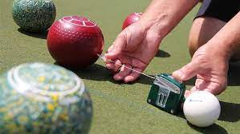

Pace The amount of force with which a bowl is delivered.
Weight The amount of force with which the bowl is delivered to execute a particular shot.
Rink The rectangular strip of the green, between 4 and 6 metres wide, on which the game takes place.
Stance Position adopted on the mat prior to delivery.
Shot bowl The bowl that is nearest the jack at any stage of play.
Take the green Instruction to remind bowlers to take a line that allows their bowls to fully bend.
Toucher A bowl that hits the jack during its original course. This bowl still counts even if it ends up in the ditch.
Wick When a bowl comes into contact with the edge of another bowl and changes its line.

